Input Tokenization and Parsing
1. Tokenization
Tokenization is the process of splitting an input command into smaller units called tokens. The input is analyzed using delimiters such as spaces, operators, and special characters.
The main steps involved in tokenization are:
- Split the input into tokens.
- Identify and handle delimiters.
- Handle unnecessary whitespace.
- Create suitable token structures.
- Validate the generated token stream.
- Debug and verify the tokenization output.
Example:
Input:
copy file.txt /home/user
Tokens:
copy | file.txt | /home/user
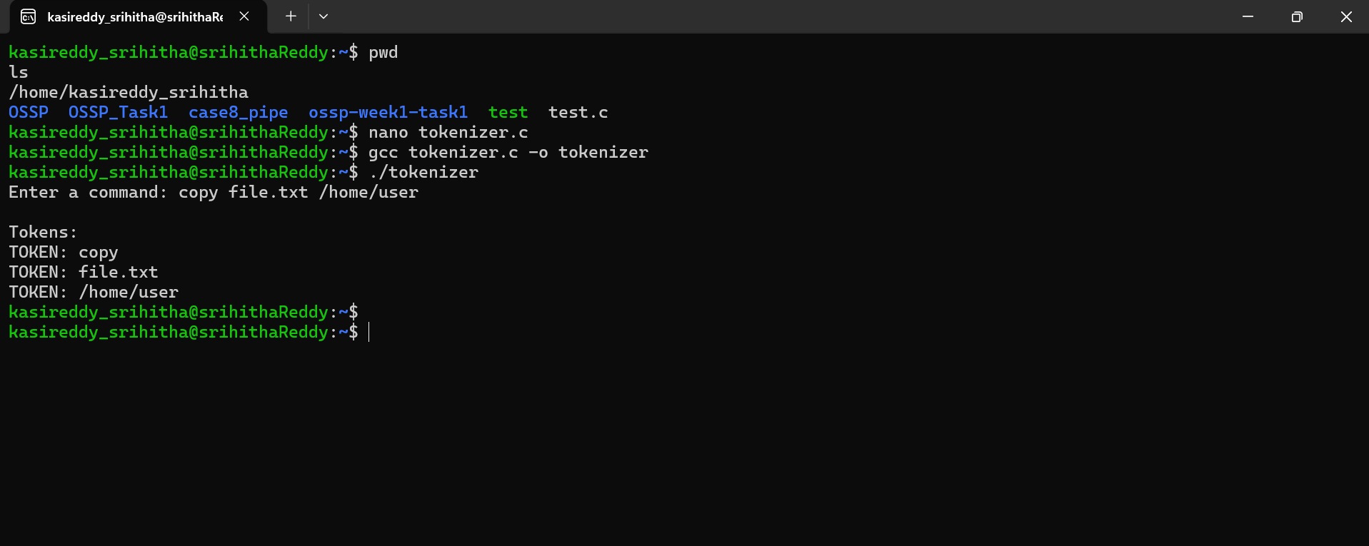
2. Parser Design
Parsing is the process of analyzing the generated tokens according to the expected command syntax. The parser checks whether the token sequence is valid and creates a structure that can later be executed.
The main steps involved in parser design are:
- Design the parser logic.
- Generate a parse tree or equivalent structure.
- Validate the command syntax.
- Detect invalid or unexpected tokens.
- Handle empty commands safely.
- Produce an execution structure from valid input.
For the command:
copy file.txt /home/user
The parser identifies:
- Command: copy
- Source: file.txt
- Destination: /home/user
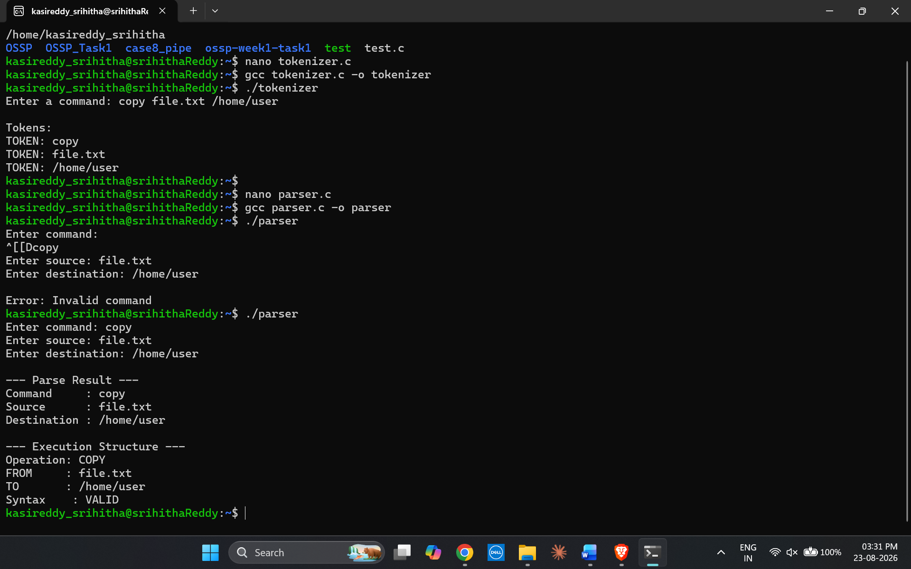
3. Syntax Validation and Error Handling
The parser should verify whether the input follows the expected syntax. If the input contains missing arguments, unexpected tokens, or an invalid command format, the parser should detect the error and display an appropriate message.
It should also handle an empty command without crashing.
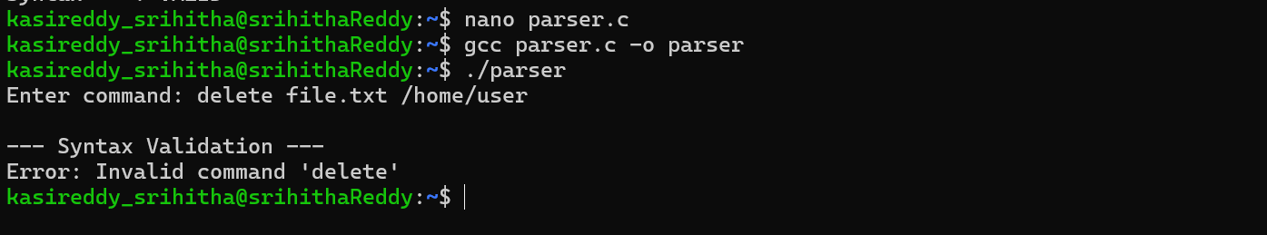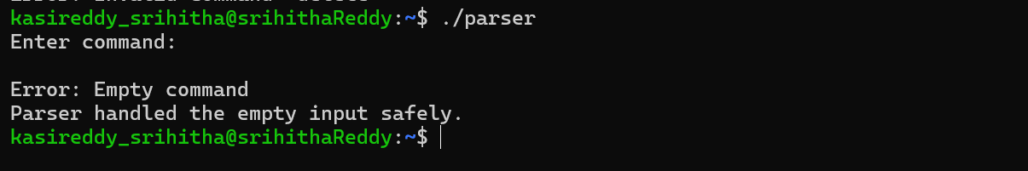

Conclusion
Tokenization converts raw input into a structured sequence of tokens, while parsing validates those tokens and converts them into an execution-ready structure. Proper syntax validation and error handling make the command-processing system reliable and easier to debug.

